ONLINE BOOK STORE :

Features:

All users:

* Login/Register
* View all books
* View pages ,ratings

Authenticated users:

* Buy books
* Rate books

Admin

* Add books
* Edit books
* Delete Books

Online Book store application helps the users to buy and rate the books online , if the users wants they can and view certain pages and ratings about the book, only authenticated users can buy the books and give the ratings

It has mainly two modules:

The admin module - only the admins can add the books , edit and delete the books

User module : It holds the features described above

Enhancements ideas:

Adding a comment features

Admin access - remove the offensive comments

Discounts options: for the first time user and combo book offers , buying more than 5 books - certain price discount

Backend - Routes

There are 3 main

Routes - Books,

User,

Order

used my the admin to do the

Books routes - add , edit , delete , get the book details by Id, get all books -

Using post man to test the restapi-

this is the route used to get the routes

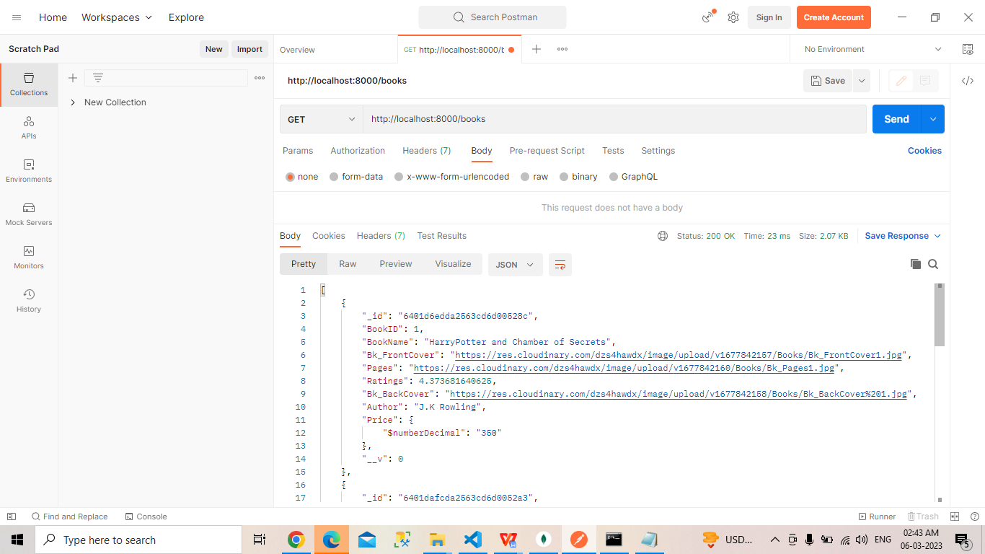

This route is used to add the book

There is a separate Api for the aunthenticated user to give ratings for books;

The images uploaded by admin will be stored in Cloud - cloudinary

The passwords are hashed and stored in DB

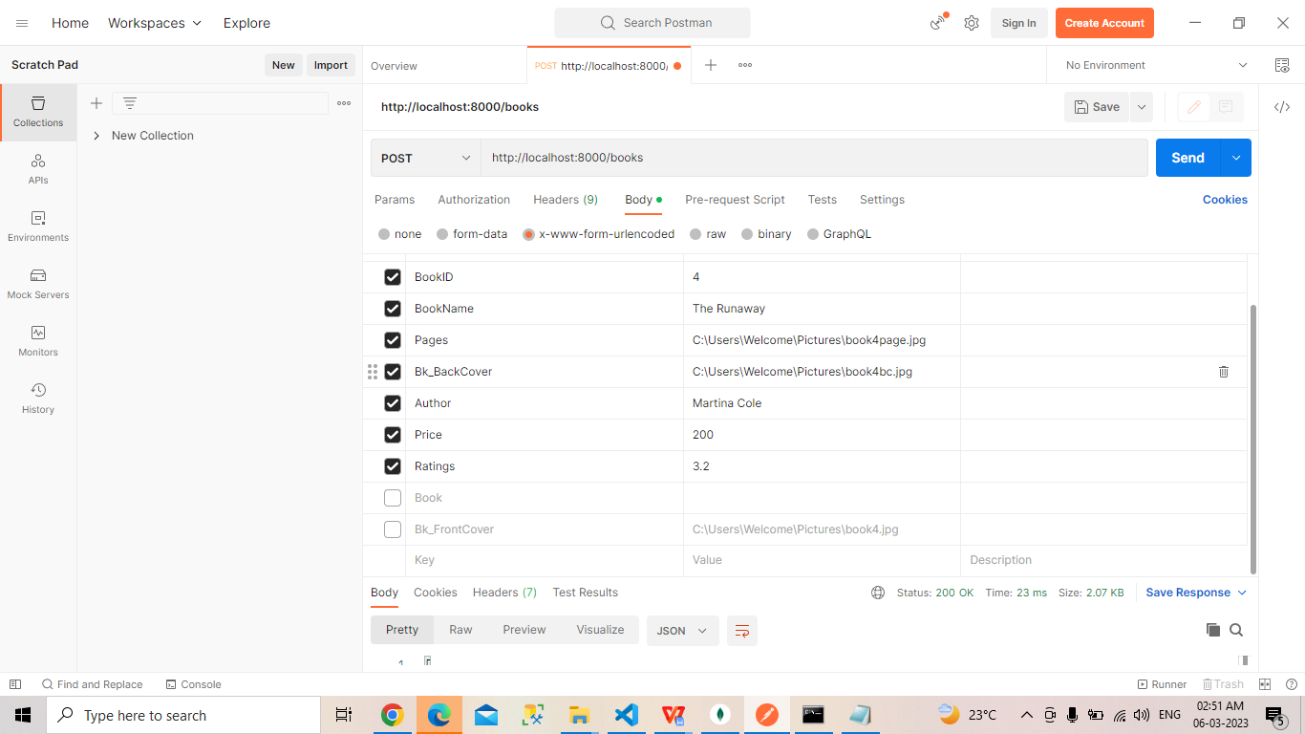

User - to add the new user and to get the user details when login

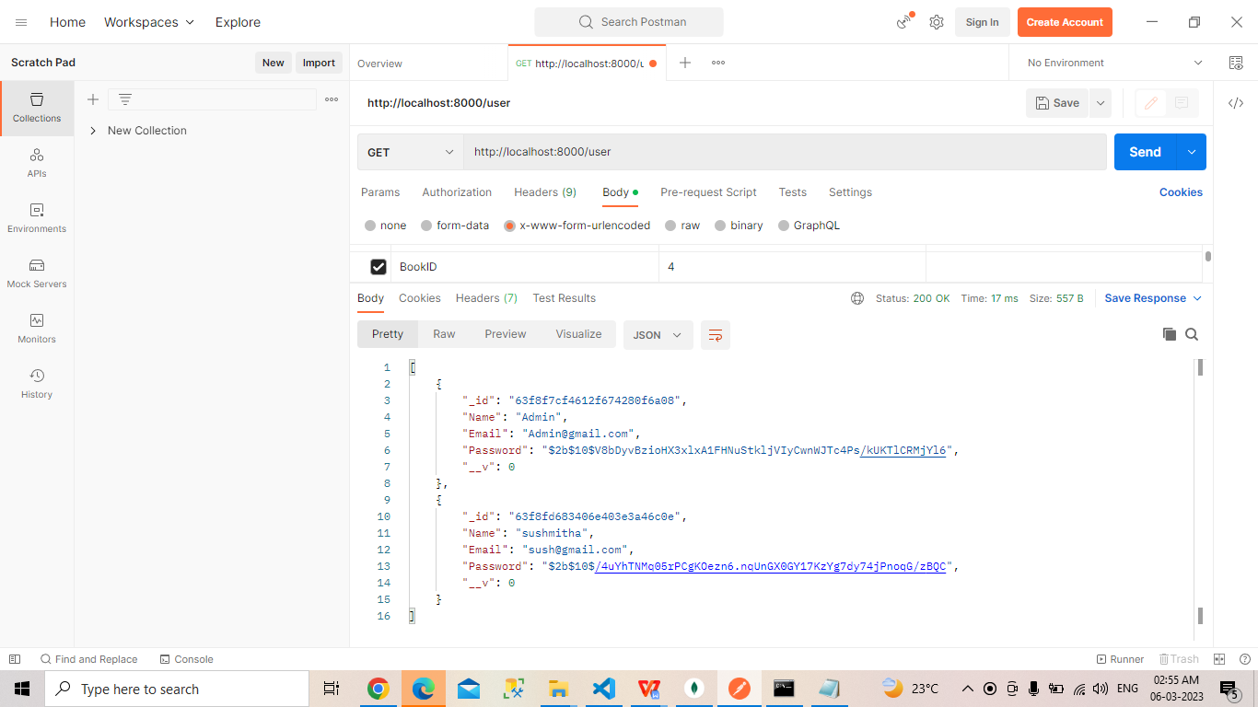

Order - to add the order , edit the order , get the order

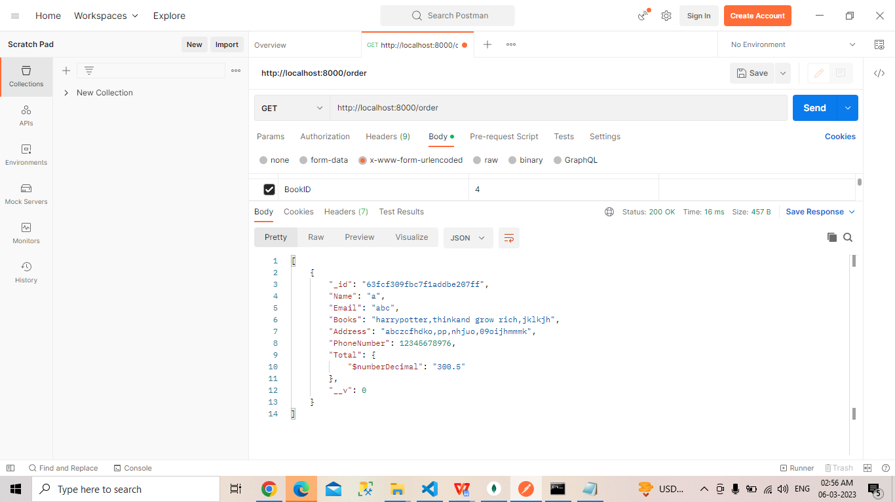

Front End -

So Far Login , signup and home page are done ,

Once user logged in the name wil be appear

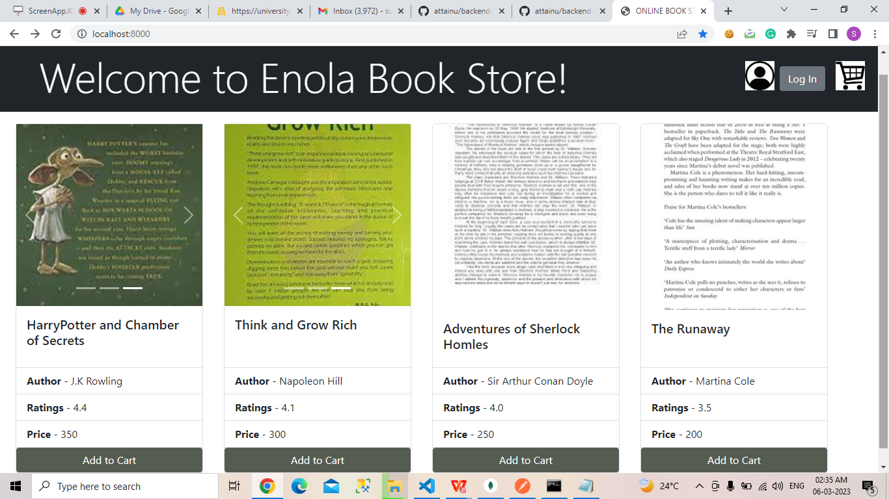

Login Page

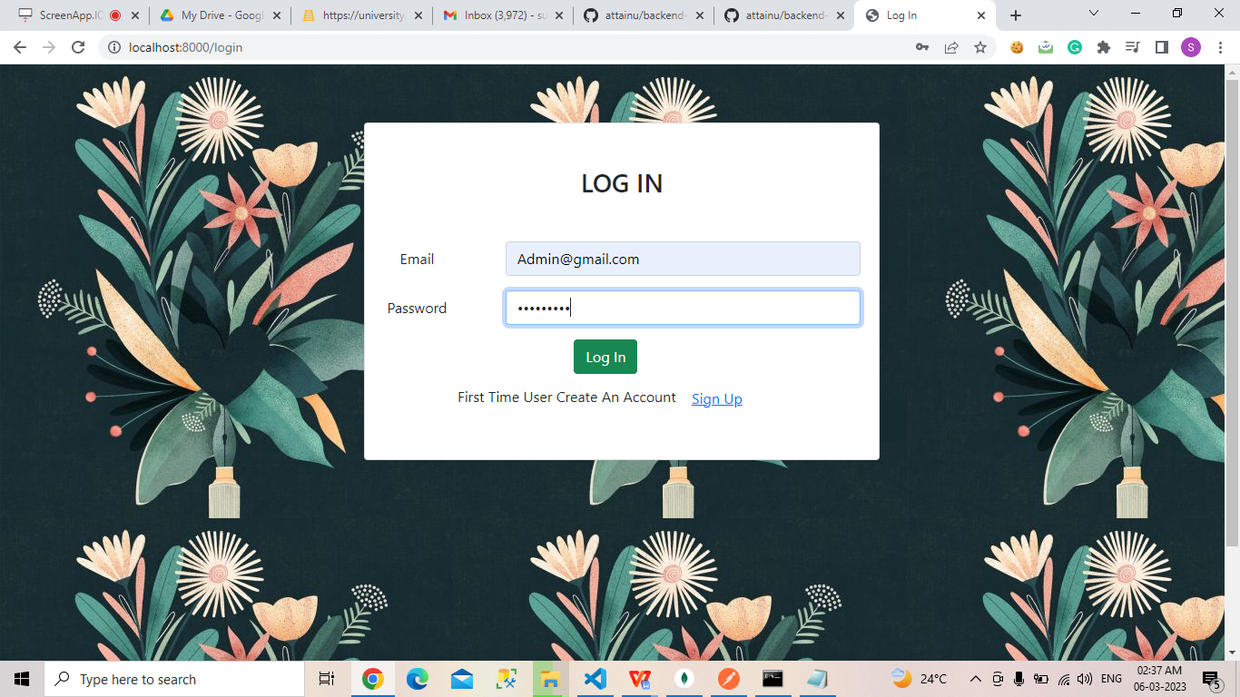

Username displayed and logged in changed to log out

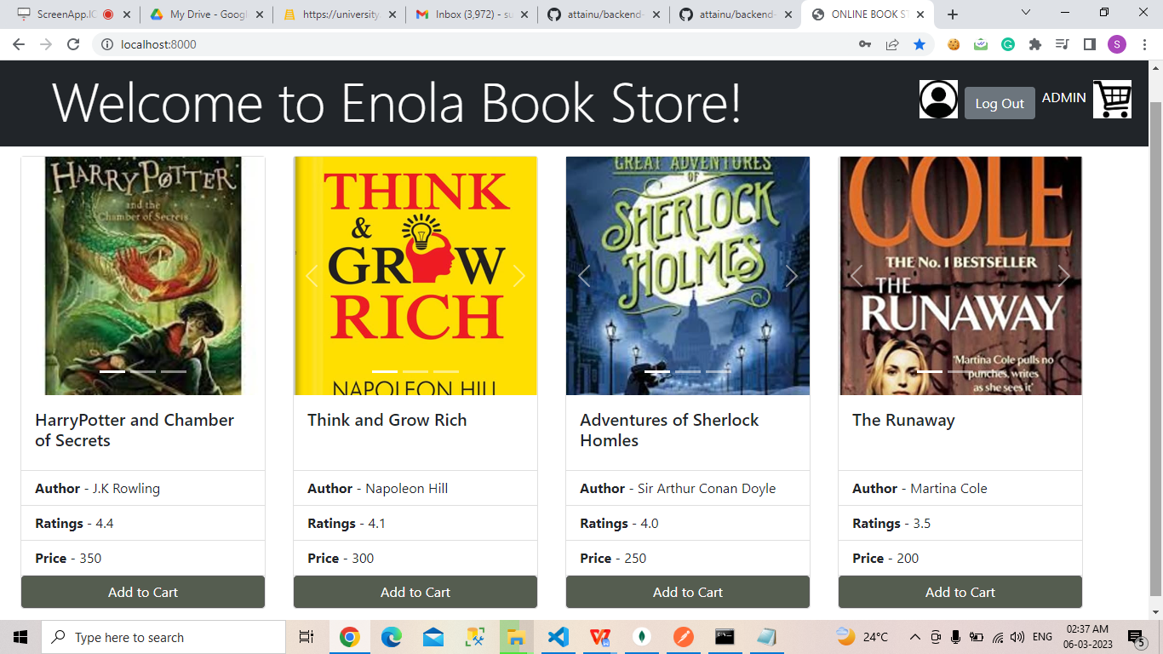

Sign UP page

